1. How many DaemonSets are created in the cluster in all namespaces?

kubectl get daemonsets --all-namespaces

1. what DaemonSets exist on the kube-system namespace?

kubectl get daemonsets -n kube-system

1. What is the image used by the POD deployed by the kube-proxy

DaemonSet

kubectl describe daemonset kube-proxy -n kube-system

1. Deploy a DaemonSet for FluentD Logging. Use the given specifications.

Name: elasticsearch

Namespace: kube-system

Image: k8s.gcr.io/fluentd-elasticsearch:1.20

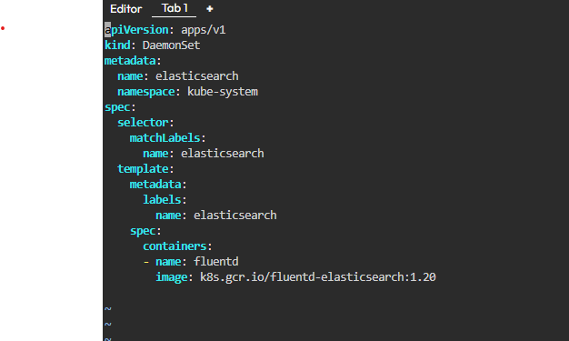

1. Deploy a pod named nginx-pod using the nginx:alpine image with the labels set to tier=backend.

kubectl run nginx-pod --image=nginx:alpine --labels=tier=backend

1. Deploy a test pod using the nginx:alpine image.

kubectl run test-pod --image=nginx:alpine

1. Create a service backend-service to expose the backend application within the cluster on port 80.

kubectl expose pod nginx-pod --name=backend-service --port=80 --target-port=80

1. try to curl the backend-service from the test pod. What is the response?

kubectl exec -it test-pod -- /bin/sh

curl backend-service

curl backend-service.default.svc.cluster.local

9- Create a deployment named web-app using the image nginx with 2 replicas

1. Expose the web-app as service web-app-service application on port 80 and nodeport 30082 on the nodes on the cluster

kubectl expose deployment web-app --type=NodePort --name=web-app-service --port=80 --target-port=80 --node-port=30082

1. access the web app from the node

kubectl get nodes -o wide

1. How many static pods exist in this cluster in all namespaces?

kubectl get pods --all-namespaces -o wide

13-On which nodes are the static pods created currently?

kubectl get pods --all-namespaces -o wide